Sentiment Analysis Following First Presedential Debate

Raghav Wadhwa
Department of Computer Science
Case Western Reserve University
Cleveland, United States
rxw301@case.edu
Aditya Kamat
Department of Computer Science
Case Western Reserve University
Cleveland, United States
axk32@case.edu

(coded the project and wrote most of report) (wrote definitions and references and helped with explanation)

Abstract—In this report we examine, summarize and present the findings involving twitter data following the first presidential debate of the 2016 U.S general election. We firstly clean the data set by removing unnecessary items such as links, stop words and emoticons. We also performed statistical analysis to give a summary of the entire cleaned data set as well as used various libraries in Python to conduct further analysis. We split the cleaned tweet data set into tweets from the two candidates Donald Trump and Hillary Clinton and performed more statistical analysis in respect to the tweets of both candidates. We illustrated the data gathered using Python.

Introduction
The presidential race in 2016 sought to bring change to the United States in terms of leadership, policy and people’s overall sentiment towards government and those running it. As the season progressed from the announcements of candidate up for election to the primary election and finally to the general election with Mr. Donald Trump and Secretary Hillary Clinton as the two candidates from the Republican and Democrat parties respectively.

Sentiment Analysis

The nations sentiment during the campaigns of both candidates is primarily produced after each one of the three debates. Various social media site as well as online blogs contained the general sentiment of the nation following the debates .The primary medium in which people expressed their sentiment and reaction to the debates and the campaigns in general were through twitter. The first debate alone generated close to 10.3 million tweets during the one hour and thirty minuets session which was the highest twitter usage during any debate in the history of the United States. The data set which was analyzed in this report was a set of 2000 tweets gathered from twitter following the first presidential debate occurring on September 26th 2016.This twitter data was gathered by a third-party source specifically datazar, a data set vendor, as the debate was in progress thus giving peoples raw sentiment regarding what was said during the debate. The data set was not cleaned originally and contained various links, emoticons which were not useful in the analysis.
Using the tweets in the data set we determined that the question to pose involved determining if there was a correlation to what each candidate said and the sentiment generated on twitter. In order to answer this question, we analyzed the data statistically by finding the average length of the tweets in characters and words as well as the variance. We also calculated the positivity and negativity of the tweets as Polarity: How positive or negative a phrase is determined by using a built-in classifier in Python. We also used Subjectivity: How factual or in factual a response is determined by a built in classifier in Python. Using these metrics and the other statistical data we could examine and answer the question regarding the relationship between the sentiment generated and the statistical components of the tweets. We were also able to determine the frequency of the most common words of each tweet for each candidate. We conducted all our analysis using Python and its various libraries specifically pandas, nltk(natural language tool kit), textblob(used for polarity and subjectivity determination),numPy(for statistical calculation) and MatPlotlib(for illustration of the results).

Structure of the Report
The report structure is as follows. First the definitions are explained in order to comprehend the report in an easier fashion. Methodologies of our data processing is then explained and illustrated. Third, the cleaned data set of tweets is presented along with the statistical analysis and information. Various figures and graphs are used to illustrate this information. The report them moves on the examine the split data sets for the individual candidates and polarity and subjectivity measures as well as more statistical analysis are measured on the two data sets. Finally, we conclude the findings examining our findings and drawing conclusions.

Definitions
  - Positive Tweet

A tweet which has a positive connotation. By the definition of the analysis, a tweet containing the words “love”, “like”, “agree”, “correct,” “great”, “good”, is considered a positive tweet.

B Negative Tweet
A tweet with a negative connotation. By the definition of the analysis, a tweet containing thewords“scandal","mistreat","hate","racist","strike","Controversy","Investigation","horrible”,,"stupid","disgust” is considered a negative tweet.

C. Polarity

The positive or negative nature of a given tweet.
D. Subjectivity

A tweet that reflects the author’s own views,
feelings, thoughts or experiences is a subjective tweet. By the definition of the analysis a tweet using words such as “I” , “My” , “My Family”, “In my view ”, “In my opinion”, “I think”, is considered a subjective tweet.

III . Methodologies
We used various methods aided by Python to generate useful information to analysis the data. These methodologies involved using the various Python libraries as described above.

Tweet Cleaning

We utilized Pythons re library to clean and process the tweets. In this procedure links, emoticons, unidentifiable characters and hashtags were removed from the data sets and the cleaned tweets were appended to a new data frame.

Naïve Bayes Classification
In order to classify the tweets in all three data sets as positive, negative or neutral we used the textblob library in python which generates a built in Bayes Classifier based on the applied data set. Each tweet was run through the textblob instance and a polarity measure was generated foe each tweet ranging from -1 to 1. Textblob also measured the subjectivity of each tweet by generating a Bayes Classifier with its lexicon of previously trained data sets. The subjectivity measure was generated for each tweet.

Statistical Analysis

We utilized basic statistical analysis such as mean, variance and standard deviation calculation. We used these methodologies on all three data sets specifically the length of each tweet in characters and in words as well as on the determined polarity and subjectivity measure.

IV. Cleaned Tweets DataSet

After cleaning was conducted the tweets were put into a cleaned tweets data frame. The data frame consisted of the 2000 tweets from the original file as well as the calculated polarity and subjectivity of each tweet. The number of positive and negative tweets was calculated and is displayed as follows: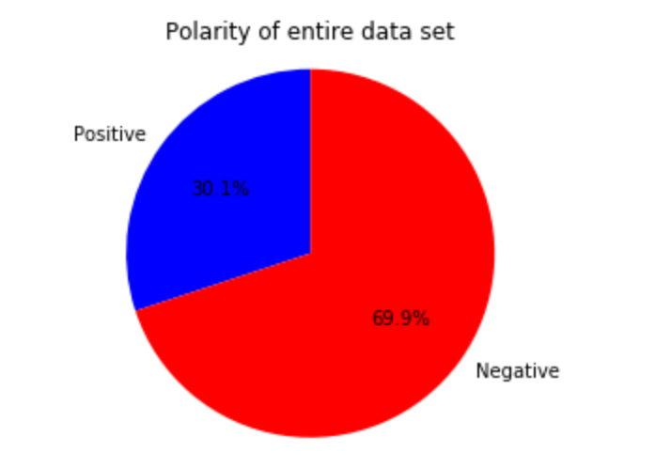 Figure 1: Proportion of Positive and Negative tweets

The tweets in the cleaned set were generally negative with approximately 69% of them having some type of negative sentiment. Approximately 30% of the tweets had some type of positive sentiment however due to sarcastic language and various other idioms used this number may be lower than what the actual number of negative tweets there are. This analysis also shows that in general the sentiment following the debate was negative signifying that most of the feelings the general public has towards the entire election is negative. To understand this polarity in a more specific way a histogram of the polarities of each tweet was generated using a bin size of .1 from -1 to 1.

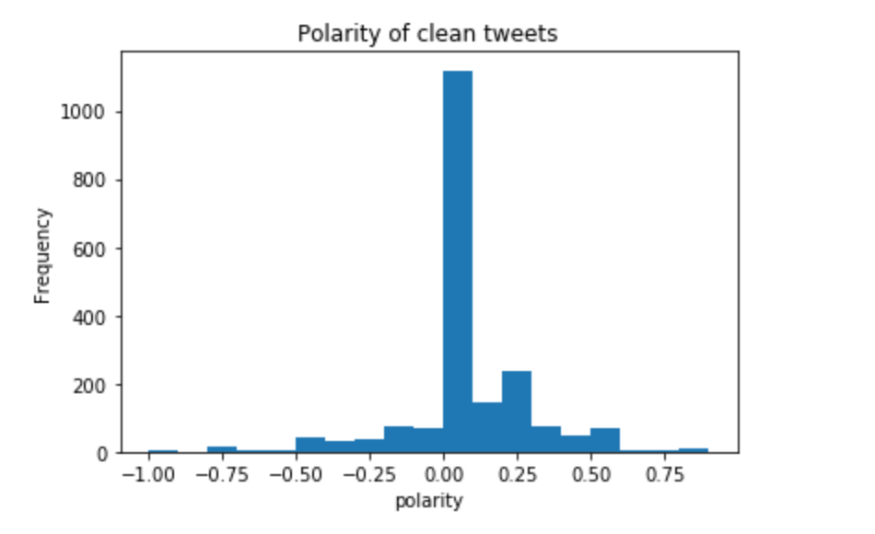

Figure 2. Distribution of polarity of clean tweets

The Distribution of the polarity is somewhat skewed to the right of the histogram showing that in terms of polarity the tweets had a majority neutral feel. Certain words contained in tweets also may have had more of a positive or negative effect than other words which affects the distribution. The distribution also had a larger amount of more negative tweets which may have been responsible for the overall negativity of the data set. Using this information gathered from the individual polarities of the tweets in the clean data set we could establish a baseline when analyzing the tweets from both candidates separately. The wide distribution to the right of the histogram may also have been as a result of incorrect classification by textblob as sarcastic and idometric tweets may have been incorrectly classified as positive. The polarity was also compared to the subjectivity of the tweets in the data set as we wanted to examine if polarity and subjectivity were related on any scale in the data set. The results showed that there was no relation between the subjectivity of each tweet and the polarity of each tweet which was no expected as usually opinions are more polar in both the positive and negative context. The scatter plot showed no linear correlation between the two.

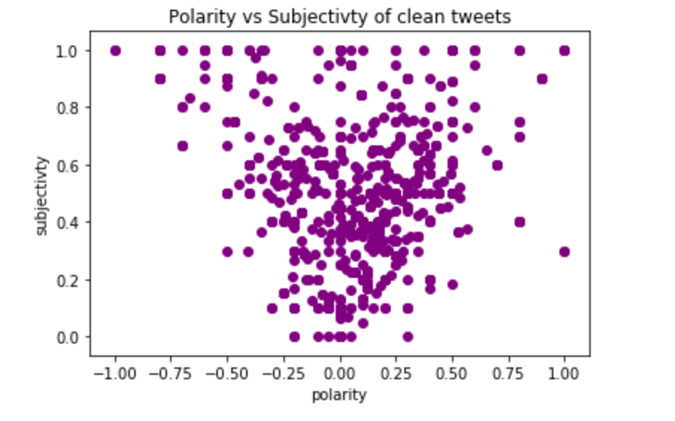

Figure 3. Polarity vs Subjectivity

As shown in the scatter plot the majority of the data points lie towards the middle of the plot signifying that most of the tweets in the data set were neutral and had a good amount of factual information. There is a cluster of points towards the top of the plot indicating that there a high number of tweets containing strong opinions spanning the whole spectrum of polarity from -1 to 1. There is also a cluster towards the left upper of the plot illustrating that there are also a large number of tweets with negative sentiment and high amounts of subjectivity which is expected in the responses after the first debate. When comparing the subjectivity in terms of polarity the information illustrates that less subjective tweets are often more neutral and more subjective tweets have a wide range of polarity.

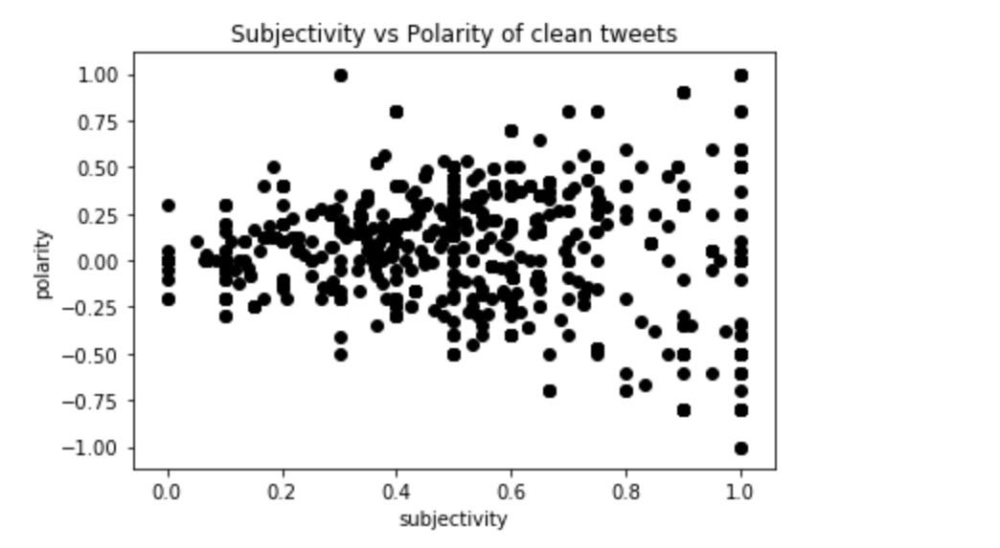

Figure 4. Subjectivity vs Polarity

The degree to which the plot widens as subjectivity increases is telling of the rate at which the polarity widens as subjectivity increases. This shows that when opinionated words are in tweets, there is a high chance that the polarity is more extreme for those cases. Polarity was also compared with the length of each tweet in the data set hoping to find some degree of correlation between the length and polarity metric. Twitter has a maximum character length of 144 which makes the max number of words at around 50-60 words. The length of each tweet regarding the number of words ranged from 5 words to 60 words making for a wide distribution of size. Polarity increases typically tweets should get longer as people usually use more words when they are displaying forms of sentiment whether positive or negative.
The results were not as expected, the length of the tweet did not seem to have much effect on the polarity of the tweet. However, there are some outliers in the 60 to 70 regions which seem to be fairly neutral, therefore we cannot conclude that tweet length has anything to do with the polarity of the tweet.

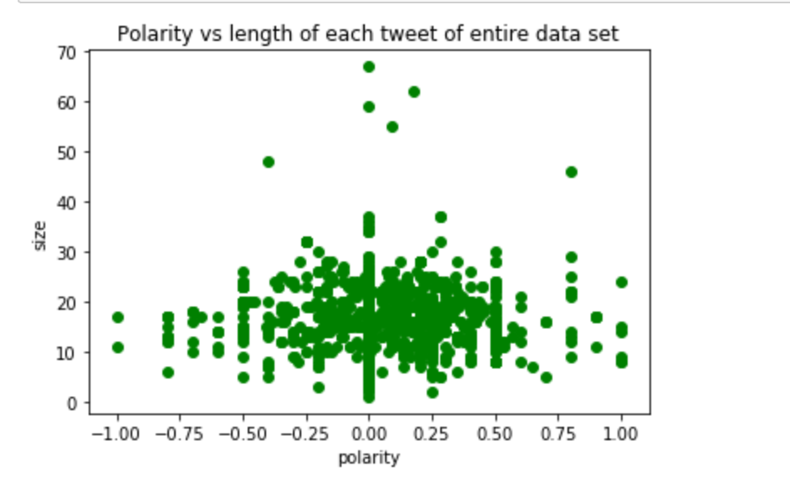
Figure 5. Polarity vs Length of Tweet

The distribution of points shown is evenly spread out across the range of polarities showing that the polarity and length have no relation. The cluster in the lower center of the graph shows that the majority of tweets lie in the range between 10 and 30 words which is the typical length of a tweet. The polarities mostly range from -.5 and .5. This bound is a good representation of the entire data set. There is also an almost vertical line at 0 polarity signifying that very ambiguous and unclear language may have been used. This ambiguity is also supported by the two large clusters in polarity ranges from -.25 to .25 illustrating that there may have been only a couple words which were classified as positive or negative when the tweets were being read. These large clusters around the neutral area show that people may not use the most descriptive and concise language when trying to describe their sentiments towards a topic in the immediate aftermath. The data set also is well described by basic statistical analysis.

Table 1. Statistical Information on the Clean Tweets
 | Mean | Variance | Std. Deviation
Length(words) | 15.64 | 31.01 | 5.57
Polarity | .0521 | .0508 | .2242
Subjectivity | .254 | .093 | .305

This statistical information presents a clear picture of the data set as a whole starting from the mean length of words of each tweet. Typical twitter tweets lie in the range between 10 to 50 words which matches up with the mean calculated for this data set. The high variance however shows that the lengths of the tweets varied considerably from the mean signifying the variation of responses at different times during the debate. Although this suggests that a large variation is present in the length, there is no correlation between the variance and the polarity of the data set as polarity has a relatively small variance in comparison to the variance for the length. The standard deviations of both entities are also relatively small suggesting that the data set does not have considerable variation as what would be expected in a sentiment analysis. The lack of subjectivity also illustrates the point that there was a considerable amount of factual information displayed in the tweets which is in alignment with the relatively neutral polarity measure both in terms of mean and variance. This is a strange finding as usually during a sentiment analysis, there is a high degree is variation in the polarity. A future study would be beneficial to understand if this trend occurs in tweets following the other two debates.

V. Anylyzing tweets from candidates

After the clean tweets data set was analyzed, the data set was broken down into tweets from the candidate from the republican party, Mr. Donald J. Trump and from the democratic candidate Secretary Hillary Clinton. Each data set had the same metrics as the clean tweets data set to define it and illustrate the various trends. The information generated from analyzing the two data sets individually also was compared and conclusions were drawn from those comparisons.

Table 2. Statistical Information on individual candidates
 | Mean | Variance | Std.Deviaton
Trump
Length(words) | 14.97 | 89.95 | 9.483
Polarity | .0294 | .0466 | .2164
Subjectivity | .242 | .093 | .306
Hillary
Length(words) | 16.22 | 23.42 | 4.84
Polarity | .0682 | ..0531 | .230
Subjectivity | .261 | .092 | .304

The information above illustrates the two divided data sets through statistical lenses. The large variance in tweets regarding Donald Trump’s shows that there was a significant variation in the tweet length. As supported by a high standard deviation this variation shows that twitter users following the first debate either for or against trump had varied expression of thought regarding Trumps responses in the debate. Trumps mean polarity measure of .0294 compared to the clean tweets polarity score of .0521 and Hillary Clintons score of .0682 shows that overall the sentiment was more positive for Hilary when compared to the combined clean tweets data set as well as Trumps tweets. Trump’s tweets also had a lower variance than Hillary’s showing that most of the sentiment gathered from Trump’s data set is centered around the low mean value of .242. When analyzing Hillary’s data set the variance is higher showing that the polarity measure has more variation towards the higher end of the polarity spectrum. Hillary’s data set also has a low subjectivity score showing that most of the tweets involving her seem to be revolving around factual information rather than opinion. This is analogous to Trumps subjectivity score which is lower showing that more of his tweets are factual in comparison to Hillary’s tweets as well as the combined data set.

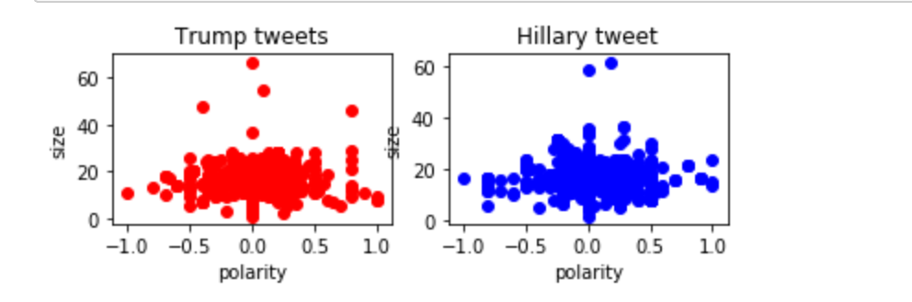

Figure 6. Polarity vs length for each candidate

The figure abover shows the relationship between the length of the tweet and polarity for each candidate. The distruibutions are relitivly similar in that the distribution of polarities of both candidaes are primarily between -.5 and .5 and the range of size is between 10 and 50 words. There are some noticible differences however, primarily in the clusters of points near the center of both plots. In Donald Trumps plot there is a large cluster of points near the left center signifying a large amount of negative sentament in the -.25 to -.5 range. This is reflected in the overall sentiment decrease from the combined clean tweets twitter data. Tweets from Hillary have a similar range of cluster points,however this is shifted to a range between .-2 and .6 thus resulting in a higher sentiment measure compared to the combined data. The results also show a almost vertical line of data points at the neutral mark which again brings up the question of ambiguous and unclear language. Due to the fact that sarcastic language may have been used in tweets for both the candidates, the overal neutrality of both the data sets may have increased as a result of a misclassification.
The polarity distribution was compared using a histogram.

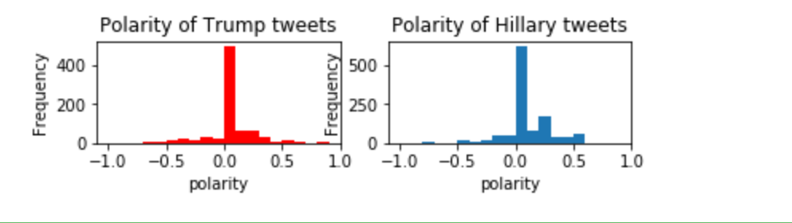
Figure 7. Polarity Distribution for each candidate

The polarity distribution painted a similar picture to the scatter plots for each candidate. When examining Trumps plot, the distribution is centered around a neutral score and has a region of slightly positive sentiment with some negative sentiment stretching to the -.75 mark. The distribution shows that Trump related tweets did not have much variation in polarity as compared to Hillary related tweets and the combined cleaned tweets data set. When looking at the distribution for Hilary related tweets, the distribution has more variance than the other two data sets. There is a region of positive polarity measurements towards the .25 to .5 area where the majority of positive tweets lie. There is also a lack of distribution of negative tweets with just a small area from -.25 to 0 which drastically lessens the negative sentiment in Hillary’s data set. Overall this distribution is a breakdown of the combined clean tweets distribution and shows the individual components of the entire data sets polarity distribution.
In addition to the polarity distribution, we also analyzed the most frequently occurring words for each candidate. The words were analyzed in the context of polarity in order to see what exact words may be affecting the sentiment of all three data sets. The words were filtered through a stop word lexicon which was generated when cleaning the data set. The most frequent words are words of significance thus we filtered out common and meaningless words such as ‘RT’ and ‘the’ etc.

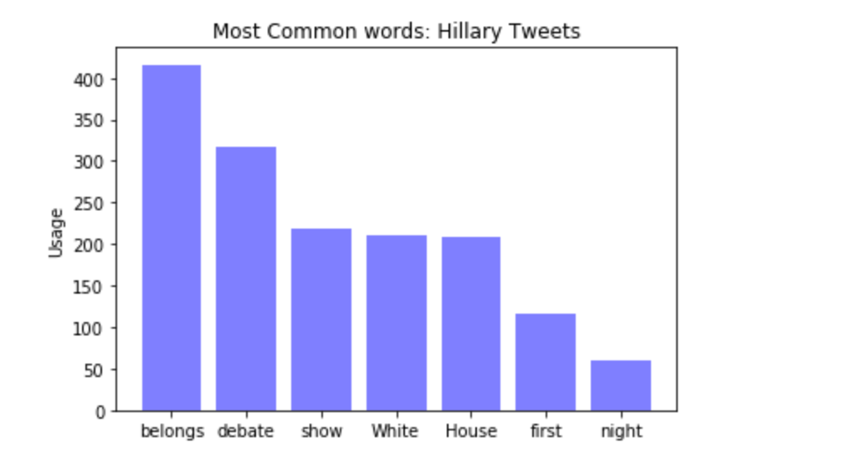
Figure 8. Most Common words in Hillary’s Tweets

The most common words from Hillary Clintons tweets have relatively neutral sentiment as in correlation with the distribution of polarity mentioned earlier. The words “belongs” and “White House” show some indication of a positive sentiment towards Hillary becoming a potential president. The high frequency of these words impact the overall sentiment of the data set and is in accordance with the higher than average polarity calculated for this data set. When examining the most common words from Trumps data set. There is a clear difference in Polarity.

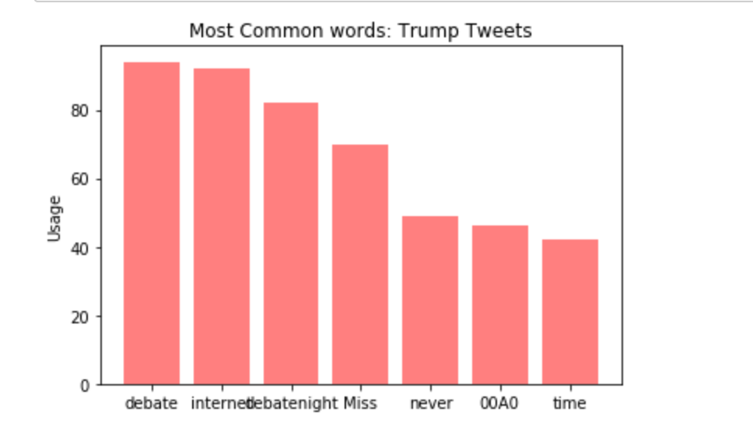
Figure 9. Most Common words in Trump’s Tweets
The most common words used in Donald Trump’s data set have a more neutral to negative sentiment as in accordance with the lower than average polarity calculated. The word “never” has the most negative sentiment out of all of the words and contributes to the more negative sentiment of Trump’s data set. The frequency of the words in general is a lot less compared to the frequency of Hillary’s data set. This is a result of cleaning the data set of stop words which ultimately were the most frequent words in the data set.

VI. CONCLUSION

In this report we have taken a data set from the an online third party vendor datazar and cleaned the individual tweets in it. We then proceded to analyze the tweets through statistical analysis as well as in term of polarity and subjectivity in order to illustrate the features of the data set. We then broke the data set down into tweets about each presidential candidate and conducted a polarity and subjectivity analysis as well as further statistical analysis as well as determined the most frequent words used by twitter users.

VII. REFERENCES

- S. Collison , “2016 Election News, Candidates & Polls,” NBCNews.com. [Online]. Available: http://www.nbcnews.com/politics/2016-election/president. [Accessed: 27-Apr-2017].
- “TextBlob: Simplified Text Processing¶,” TextBlob: Simplified Text Processing — TextBlob 0.12.0 documentation. [Online]. Available: https://textblob.readthedocs.io/en/dev/. [Accessed: 27-Apr-2017].
- A. Tsegai, “Datazar - Home to Research,” Datazar - Home to Research. [Online]. Available: https://www.datazar.com/search/data/?q=presidential debate. [Accessed: 27-Apr-2017].
- [1]B. Stelter, "Monday night ranks as the 'most tweeted debate ever'", CNNMoney, 2017. [Online]. Available: http://money.cnn.com/2016/09/27/media/debate-social-media-twitter-facebook/. [Accessed: 27- Apr- 2017].

